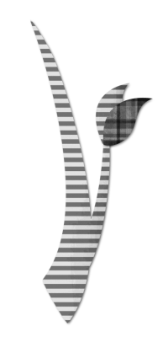**CLS 50th ANNIVERSARY**

**OPEN HOUSE AND SERVICE SHOOLS**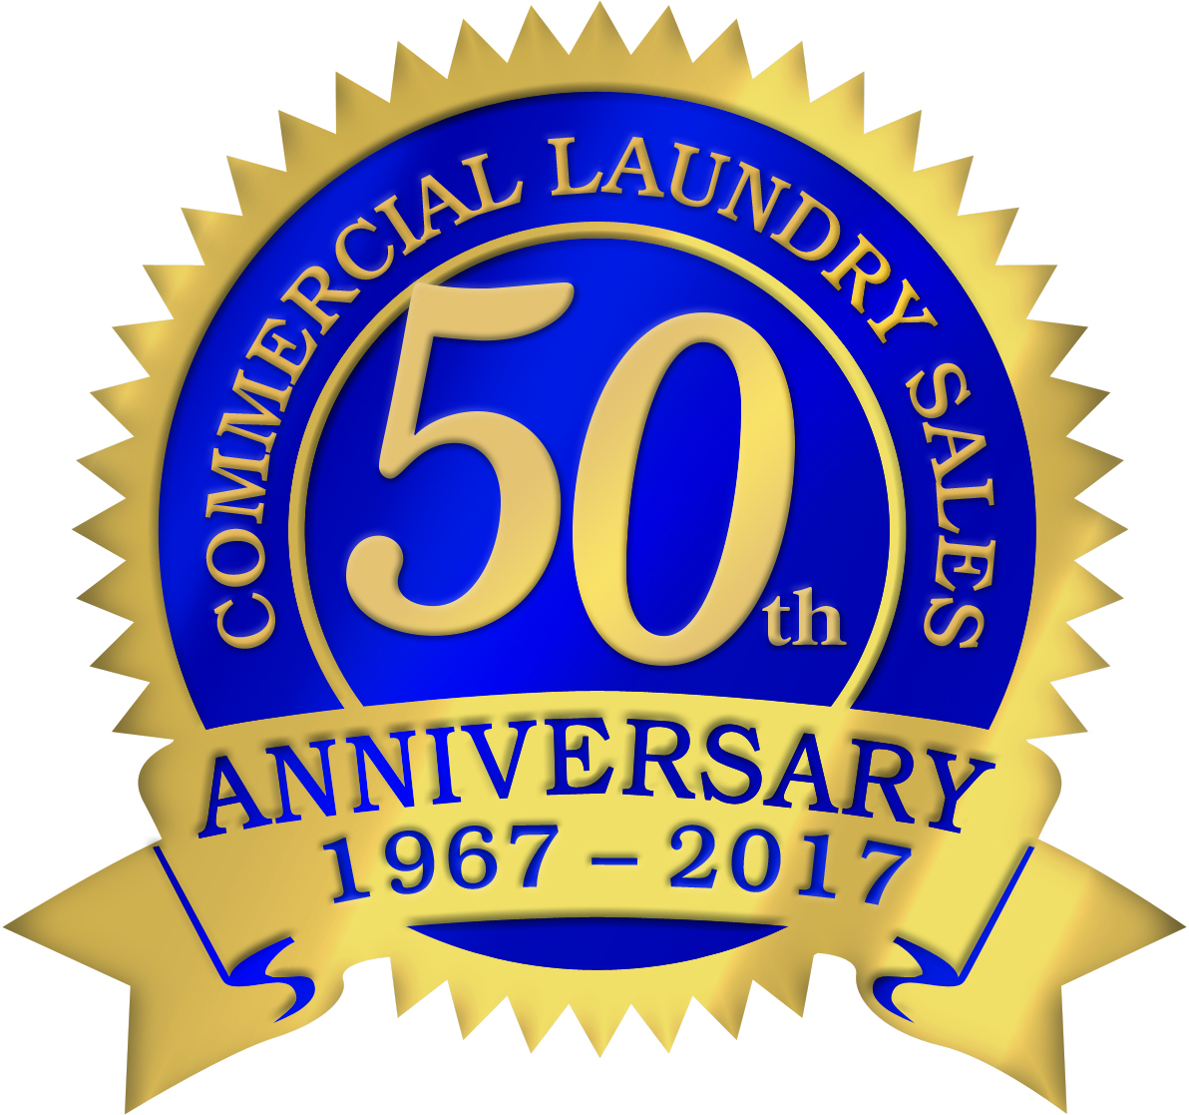

## Tuesday

## May 2nd

## 8:00 am

Doors open

## 9:00 -10:30 am

**Dexter** washer/extractor service school

## 10:45 – 12:00 noon

**Dexter** drying tumbler service school

## 1:00 – 2:15 pm

**Speed Queen** OPL washer/extractor service school by Terry Brousseau

## 2:30 – 4:00 pm

**Speed Queen** OPL drying tumbler service school by Terry Brousseau

RSVP TO ATTEND

800-662-8356

COMMERCIAL LAUNDRY SALES

1130 Elizabeth Street

Green Bay, WI 54302

***Door Prize Giveaways!***

***Parts and equipment specials!***